Scientific Practice Notes

# Scientific practice

## solutions

### electrolytic solutions

Ionic dissociation occurs when the addition of a solvent or energy in the form of heat causes molecules if crystals of a substance to break down into ions.

### Osmotic effects.

spontaneous net movement of solvent molecules through a semipermeable membrane

### tonicity

#### hypotonic

lower ions concentration, high solvent concentration lower osmotic pressure

#### hypertonic

higher ion concentration, higher solute concentration, lower solvent concentration, higher osmotic pressure

#### isotonic

equal osmotic pressure. and solute/solvent concentrations.

### Ideal Solutions

an ideal solution is a solution which has a enthalpy of solution equal to zero NOTE: bonds forming releases heat energy. FR: the concentration of water in a typical cell is 55molar.

### concentration measurements

#### molar/molarity/molar concentration

concentration of solute in a solution in terms of moles of solute per volume of solution

#### molality

concentration of solute in a solution in terms of moles of solute per mass of solvent.

#### Other measures.

%w/w weight of solute per weight of (solvent?)

%w/v weight per volume.

%v/v volume per volume.

#### osmolarity

concentration of solute as total number of solute particles per litre (?)

#### osmolality

Concentration of solute as total number of solute particles per kilogram.

####osmol number of solute particles which contribute towards the osmolarity of the substance.

##Life Molecules

### Basic list

* Carbohydrates (2%)
* Lipids (2.5%)
* Proteins (15%)
* Nucleic Acids (RNA 20% E. Coli < 10% mammalian DNA is functional )
* Inorganic ions (3% Salts, 1% small metabolites)
* water (70%)

### Water

#### general properties

covalent bonds. dipole moment.

##### hydrogen bonds.

many hydrogen bonds are formed which together gain considerable strength.

Hydrogen bonds are typically up to $ angstroms in length, which a strength of 2-10kcal/mol.

NOTE: the advantage of hydrogen bonds is that they do not take too much energy to break down so the body can readily re-purpose/recycle organic compounds.

##### polarity

high polarity means water has a large ability to stabilise other charges

##### 

auto ionisation. water can auto ionise into hydroxide ions and hydronium ions, the concetrations of which in solution can be measured by pOH and pH respectively.

##### Solvation of ionic and polar solutes

Where D is a measure of solvent polarity.The higher the polarity, the greater the ability to stabilise charges. water forms solvations shells around each ion.

##### Solvation of apolar groups and molecules (the hydrophobic effect)

free amphipathic molecules will associate in water to form hydrophobic internal environments. molecules (amphipathic molecules contain both polar and a polar groups )

###### Examples

Integral proteins within the cell membrane are amphipathic, and allow for non polar channels through the membrane.

fatty acids form micelles (globules) and bilayers in water.

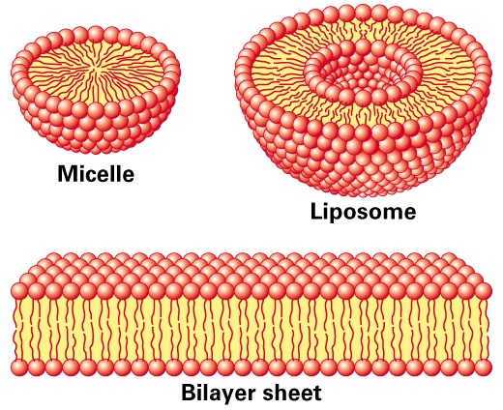

hydrophobicEffect

###### Septicaemia

Certain bacteria, respond to antibiotics by releasing proteins which punch holes in the cell surface membrane creating freely permeable pore through which cell contense can leak out, and killing the cells.

#### water and protein structure

water proteins can be buried in the interior of protein structures where they may furfill vital functions

##### examples

proteases only work if the have a water molecule imbedded within their internal structure, without this one molecule the entire enzyme becomes inactive.

other examples are reverse transcriptase and HIV protease and GST (detoxifying enzyme) which all rely on water molecules to function.

## Acids and Bases

### Bronsted and lowery

acids are proton donors bases are proton acceptors. difference between acid/base and its conjugate is a proton.

### lewis

acids are electron pair acceptors bases are electron pair donors.

#### lewis bases

* alchohol
* organophosphates.

### buffering

relies on weak acids or bases which do nto fully dissociate.

# Scientific Reasoning

## Basic structures of an argument

### Premises

A Premise is a statment. This statement may be true or false.

In science the orginial premise is known as the hypothesis. this hypothesis will be tested, usually impirically.

### Conclusions

A conclusion should be well supported by all premises. The conclusion leads one to decide if the hypothesis is true fo false.

## A good argument

A good argument can be deductively, or nondecuctive but abductively, or inductively strong.

NOTE: Arguments can be invalid even if all of the premises and the conclusion are true. If they do not actually imply eachother then it is simply a collection of facts and not an argument.

### Deductive arguments

#### Conditional

#### Contrapositive

#### Converse

#### deductive validity

1. Are the premices true (this is difficult if not impossible to establish in mathematics. )
2. Do the premices guarentee the truth on the conclusion.
3. does the argument beg the question (Not really one of the criteria)

### Non deductive arguments

most of science is actually non deductive reasoning. science will often venture conclusions beyond the scope of observation (induction).

#### Inductive Reasoning

In Inductive reasoning premises are veiw as strong support of the truth of the conclusion. however they do not garuntee the truth of the conclusion. Induction allows for conclusions to be made about issues outside the scope of ovservation.

##### Inductive strength

two factor influence the inductive strength of an argument, sample size and bias.

### Deductive arguments

### Abduction

abductive arguments seek to explain what is observed, otherwise known as inference to best explination.

#### Abductive arguments

abductive hypothesies should be able to predict easily testable results, such that if the predicted result is achieved during experimentation then the validity of the hypothesis is supported, and if it is not the hypothesis can be rejected.

(Abductive arguments usually rely on a number of assumptions which can be supported by the predictive power of the argument)

NOTE: if testing two alternative theories H1 and H0 then a good test experiment will be set up such that the the observation of event P supports H0 and negates H1 and visa versa.

#### Evaluating Abductive Inferences.

##### Surprise principles

If an observation supports a hypothesis, then it must strongly favour that hypothesis over others with which it competes

In order to satisfy this principle: 1. the hypothesis should make no fasle predictions 2. Within the set of true predictions which the hypothesis makes, there should be predictions which are expected NOT to come true if the hypothesis is false (Is this not mixed up somewhere?)

##### Abductive fallacy

A widely used and accepted expination is not necessary at all plausible, (even if no competing explination exists)

### Making observations

obervations can be made by human senses as well as by sophisticated scientific equipment.

#### examples

##### Medelian genetics.

mendal made conclusions very far beyond his premises, abducting from color change to the existance and role of gentic elements.

## A bad argument

### Circular arguments.

# Definitions

### Premise

A Premise is a statment. This statement may be true or false.

### Conclusion

### Bias

factors which may skew the results of a test in some form.

# Steriochemistry

## Rotamers

Isomers which can be interconverted by rotation (of a given part of the molecule) about a particular bond

Different isomers are known as Isoforms.

NOTE: bonds within molecules can lengthed, shorted,bend and rotate, depending on what stresses are excerted upon them.

### Newman Projections

A visualisation of a moleculeviewed from the front.

the front atom is reprisented as a dot the back atom is reprisented as a circle.

### Conformations

#### Staggered

Surrounding atoms/hydrogens are all equally spaced.

this conformation is more stable for two reasons

##### Steric Hinderance

in the eclipsed conformation outside atoms are forced to close to eachother, raising the energy level of the conformation

##### Hyperconjugation

stabilising interactions of the electrons in a -bond (usually C-H or C-C) with an adjacent empty or partially filled p-orbital or a -orbital to give an extended molecular orbital that increases the stability of the system)

#### Eclipsed

Outside atoms line up with each other.

#### Dihedral Angle

There is a whole range of conformations depending on the exact angle of rotation. 1. anti (180 orinetation) 2. gauche (60 orientation)

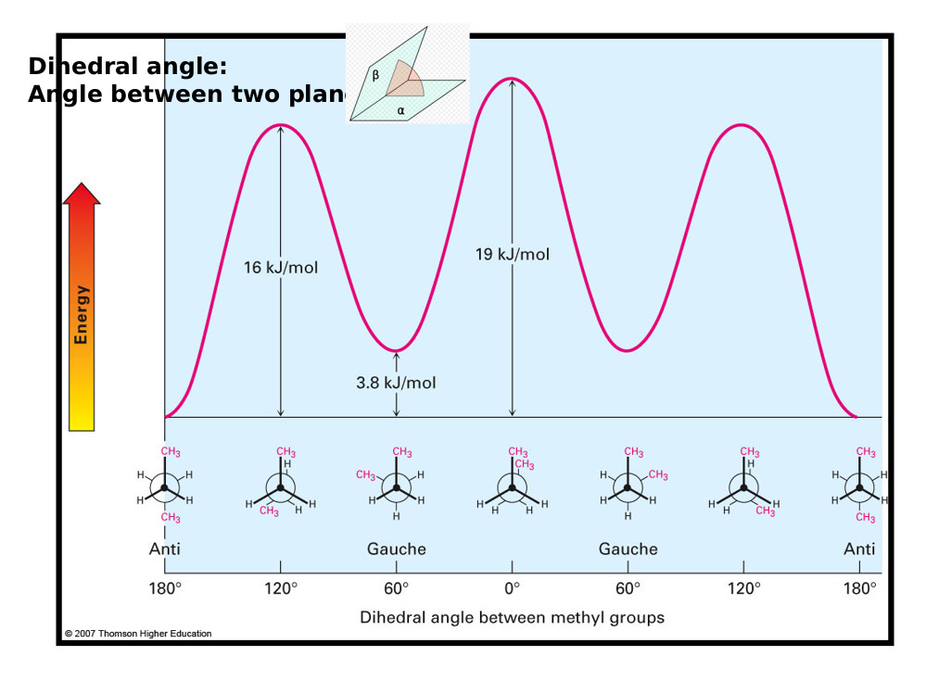

Rotamer Energy Diagram

##### Protiens

protiens also exibit a dihedral structure with peptide bods forming planes whith a given angle between them

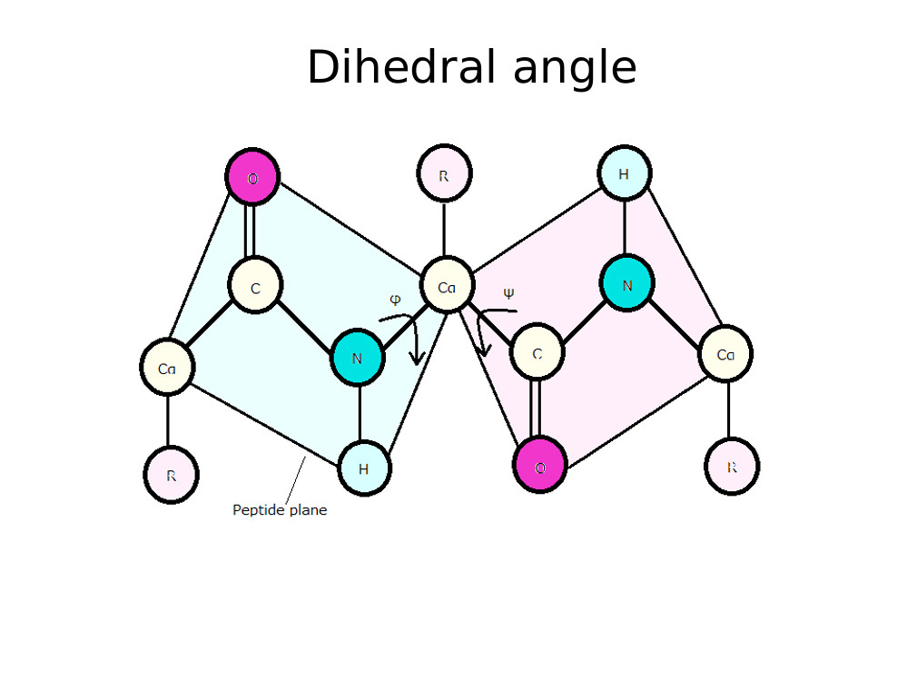

Proteins Dihedral Angle

this angle can be calculated which is very useful as most protein analysing techniques are very low res (for example obsorbance spectra to distinguish protein (max absorbance 280nm) from DNA/RNA (max absorbance 260nm) )

###### Solving protein structure

1. complex maths in necessary (furner(?) transfer analysis)
2. complex measuring equipment is needed.

## Inantomers.

### Enantiomers

opposite conformation at all chiral centers.

#### Chiral compounds

a chiral compound consists of four separate atoms bonded to one central (tetrahedral,carbon) molecule.

NOTE: this central carbon atom will always be hybridized.

##### Optical activity

certain molecules rotate plane polerised light to the right (dextrorotatory + ) or to the left (levorotatory - )

the exact degree of rotation depends on the length of substance which the light is shon through, the composition of the substance, and the optical properties of the substance.

###### Poleriser

only allows light of certain phases (that is light with a particular electric and magnetic component) through. the light alowed throguh is now plane polerised.

###### Analyser

observes/ analyses how light interacts with certain molecules.

### Diastereomers

opposite conformation at some chiral centers.

#### Allo Diastereomers

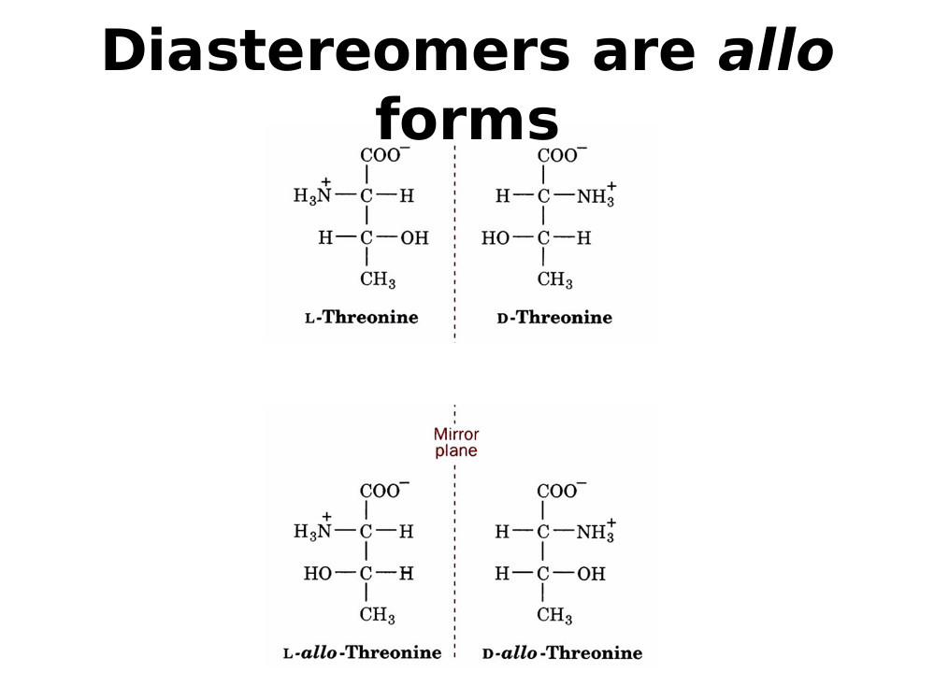

Allo Diastereomers

#### Messo Diastereomers

2S3R mirror image is 2R3S, also possilbe to be identical but rotated by 180 degrees.

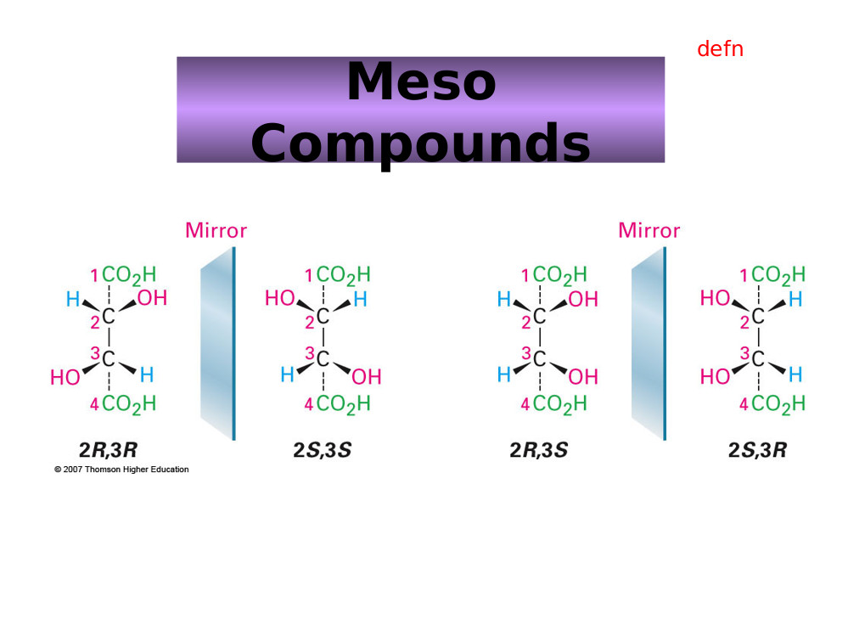

Messo Diastereomers

### Drawing structures

#### simple system

1. wedges indicate bonds coming out of the page
2. straight lines are in the line of the page.
3. dotted line are receding back out of the page.

#### Fisher Convention.

2 dimentional reprisentation of a three dimentional molecule.

The stereocentre furthest from the anomeric centre. The rotation brings about two distinct configurations, and – anomers) 1. For sugars if the OH group is on the right it is a D sugar. 2. If it is on the left then it is an L sugar. 3. vertical lines reprisent atoms thatpoint away from the viewer. 4. horizontal lines reprisent atoms that point towards the viewer. 5. the point of intersection between thevertical and horizontal lines reprisents the centeral carbo atom.

NOTE: the anomernic carbon is the carbon single bonded to two oxygen molecules.

##### Amino Acids

NOTE: natural Amino Acids occur in the L form only.

NOTE: appart from glycine all amino acids are chiral.

###### D and L convention

L amino acids have the group on the left side, D antomers have it on the right side.

###### CORN.

along the line between th COO and N group, if R is left of the central Carbon atom the antomer is L, if R is right the antomer is D.

Alternative if the molecule is orinetated with the H group dirrectly behind the centeral carbon. then if CoRN reads clockwise the antomer is a D amino acid, if it reads Anticlockwise it is an L amino acid.

###### R and S (find what R and S stand for)

more generally applicable

each atom around the central carbon is assigned a priority based on its atomic number (lower atomic number ) lower priority. (if two atoms have equal atomic numbers then the atomic numbers of their side groups are checked and so on outwards until an order can be established)

###### Cahn-Ingold-Prelog Convention

Uses the R, S system but is still based on glyceraldehyde. 1. priorities are assigned 2. the molecule is orientated so that the lowest priority group is dirrectly behinf the central carbon atom. 3. if the remain molecules arrange clockwise in terms of priority (highest to lowers) the molecule is a R antomer, if they arrange counterclockwise the molecule is a S antomer

NOTE: D sugars have the R conformation and L sugars have the S conformation.

#### Racemates

rotate light equally in both dirrections with no net effect, usually made up of equal concnetrations of opposite chiral molecules.

#### chirality in nature

usually only one isomer is present due to enzymatic selection

#### chirality in drug design

It is vitally important that the right isomer is used.

##### examples

1. Prozac (S prevents migraine, R does nothing)
2. thyidol (?), both effective to supress morning sickness but wrong insomer can lead to birth defects.

#### Prochirality

A molecule is said to be prochiral if it can convert from achiral to chiral in a single chemical step. (such as the addition of a group to a planar hybridized molecule, or by the substitution into a tetrahedral molecule.

##### Face

the dirrection/ orientation in which a molecule binds. ) Face is related to the need to assign prioritory values to differentiate between identical groups in a prochiral molecule. this identification and the idea of face is imprtant because enzymes will favour which one of the identical groups to act upon depending on its orientation with respect to the rest of the molecule (its face)

# Electrophoresis.

## Background.

Electro refers to the flow of electrons/current. Phoresis refers to moviment (of sample elements)

### Definitions

Electrophoresis is a separation method where by charged molecules in solution, most commonly proteins of nucliec acids, migrate in respose to an electric field.

NOTE: As Electrophoresis is the moviment (of sample consitituents) under electric current,electrophoresis can only be used as a separation technique for molelecules which will move within an electric field ie charged molecules.

#### Cathode

The cathode is the negatively charged electrode. Cations (positively charged ions) will be attracted to and move towards the cathode during elecrophoresis.

#### Anode.

The anode is the positively charged electrode. Anions (negatively charged ions) will move towards the anode during electrophoresis.

### History

Arne tiselius. nobel chemistry prize for electrophoresis and adsorbtion analysis, especially complex nature of ther serum proteins.

#### Cell

bend glass tube with electrolyte reservior containing cathode and anode, and a buffer containing sample molecules to be separated. Horse serum tested gave four different bands. Albumin and 3 globulins ().

## Rate of migration

### Affecting fators

#### Field Strength.

Higher field strength will lead to faster moviment but it may also in turn heat up the gel destroying its structure.

#### Net charge (sample molecules)

#### Size

Smaller molecules will move faster as they have an easier path through the gel.

#### Shape

More spherical molecules will move faster and then linear molecules of the same molecular wieght, as they will be able to move through pores regardless fo their orientation. linear molecules will have to line up correctly (with their long side more of less purpendicular to the pore), to be able to pass through the pore.

supercoiled nucleic acids will migrate faster.

#### media/solution porperties.

##### Ionic strength

Higher ionic strength will lead to more shielding and hence slower moviment (?)

##### Viscosity

Higher viscosity will result in slowr moviment through the gel.

##### Temperature.

Higher temperature (provided the structure of sample consitiuets is not disrupted) will lead to faster moviment through the gel.

#### Voltage

#### Intercalculating dyes.

### Equation

where:

=Mobility q= net charge E= field strength () r= molecular radius

NOTE: r is also commonly reffered to as frictional coefficient f, and is dependant on size.

#### Relating resistance, voltage, current, and power.

##### Ohms law

Increased voltage with constant resistance increases current. Increased current leads to increased heat which must be dissapated or it will be absorbed by the system. Too much heat can cause the sample to migrate irregularly within the sample lane, leading to sample bands which form a “smile”, in the extreme case the gel can literally fall apart.

##### Power

()

## Set up

Slab gel electrophoresis can be performed ither horizontally or vertically. If run vertically samples are introduced into the wells at the top of the gel.

NOTE: In electrophoresis one parameter, resistance, voltage, current, or power is always held constant.

##### Constant current

Velocity of molecules is constant, but heat is generated.

NOTE: velocty is dirrectly proportional to current.

##### Constant voltage

velocity will slow (over the course of the reaction), but heat is generated.

##### Constant Power.

Velocity slows, but heat generated is kept constant.

## Set up

Slab gel electrophoresis can be performed ither horizontally or vertically. If run vertically samples are introduced into the wells at the top of the gel.

### Electrode

The negative electrode is black. the positive electrode is red.

### Wells

The well are created by inserting a comb into the set up before the gel is set. Once the gel is set the comb can be removed, leaving evenly sized, evenly spaced wells where the teeth of the comb used to be.

#### Regular comb

The wells are separated by an “ear” of gel

#### Houndstooth comb

The wells are immediataely adjacent.

### Gel

#### Function

The solid support matrix inhibits convection and diffusion which would otherwise impede separation of molecules, and allows for a permanent record of the results. It can provide additional separation (by size) through molecular sieving.

NOTE: A perminant record is made through staining after running, and trichloroacetic acid which acts as a fixing agent for proteins.

#### Structure

Both agarose and polyacrilamide gels are porous in structre. A porous gel acs as a sieve by retarding or, in some cases, by completely obstructing the movment of macromolecules while allowing smaller molecules to migrate freely. A gel with a restrictive pore size can differentiate sample molecules based on size. Both gel types are also relatively electrically neutral.

### Polyacrylamide.

Polyacrylamide is a cross-linked polymer of arcylamide. It can be used to separate molecules from 0.2-500kD, eg most proteins and oligonucleotides.

NOTE: Acrylamide is a potent neurotoxin.

### Concentration

Polyacilamide gels% are made at 3.5-20% by mass.

### Agarose.

#### Structure

Agarose is a polysaccharide, harvested from rhodophyceae algal cell walls. Alternating sugar units form linear chains. These two subunits are and . These chains are cross-linked via hydrogen bonding to form the porous matrix. Cooling a liquid form of the gel forms a matrix with an ‘average’ pore size.

To make the gel, a solid sample of agarose, in a random structure is heated from menting from , the inital gel structure begins to form as unifrom cooling takes place, and by the time the gel has cooled back to room structure it has taken on its final porous conformation. Agarose gel will dissolve again if immerced in boiling water only solidifying when the temperature is lowered to about

The pore size of the gel can be predetermined but by adjusting the cencentration of agarose in the gel.

Agarose gels are fragile as they are hydrocolliods and they are held together by the formation of weak hydrogen bonds and hydrophobic interactions.

NOTE: heat can break these H bonds breaking the matrix apart.

#### Function

Used for separating large molecules 8-800,000kD. Agarose is effective at separating these larger molecules, such as nucleic acids and protein complexes because of its larger pore size.

#### Concentration

Agarose gels are made to be 0.5-5% agarose by mass.

### Buffer

In most electrophoresis units the gel is mounted between two buffer chambers containing separate electrodes so that the onyl electrical connnection between the two chambers is through the gel.

#### Function

The function of buffer is to carry current and protect samples.

#### Types

1. Tris Borate EDTA (TBE).
2. Acetate EDTA (TAE).
3. Tris Phosphate EDTA (TPE) used most often for DNA.
4. 10mM sodium phosphate buffer: used for RNA.

Buffer additives can also modify sample molecules such as (denaturing agents)

### Dye

Tracking dye is loaded to keep track of the moviment of sample consituents on the gel, the tracking dye is visible during the electrophoresis process and moves just ahead of the samples.

### Loading adgent/dye

The loading adjent or density agent is used to to weigh down the sample so that it remains in the wells, and does not move through the buffer above the gel.

## Detection

Bands are ditected on the gel by staining during or after electrophoresis using a number of different stains.

### Stains

#### Ethidium Bromide

Ethidium Bromide is used to mark double stranded DNA. It is flourescent under UV light.

#### SyBr green or Sybr gold.

Used to stain single or double stranded DNA, or for RNA.

#### Silver stain

Siler stain is a more sensitive tha the SyBr gells but is also used for single or double stranded DNA or for RNA, or even for proteins.

#### Coomassie blue

Commassie blue is used for proteins.

## Interpretation

Molecular weight markers, using fragments of known size are run along side sample for comparison. A semiquantitive measure can also be obtained by comparison of band intensity.

## Proteins

The net charge on proteins is derrived from amino and carboxylic groups on it sode chains and terminals.

### Charge

#### PH

Charge is dependant on pH as R groups of the protein will posses different charges based on the pH of the solution. The exact responce of a given protein to PH change will depend on the particular amino acids which make up that specific protein.

NOTE: Proteins are amphoteric as they possess both basic and acidic amino acids.

## Nucleic acids

Nucleic acids are loaded at the the cathode and move towards the anode,  
### Charge Nucleic acids are always negatively charged due do their phosphate backbone.

## RNA

### Process

#### Buffer

RNA is heated in dilute formamide or glyoxal(which form part of the buffer solution) to prevent formation of secondary structures. Therefore RNA electrophoresis is said to use denaturing gels.

#### Quality

RNA qualtiy can be determined by the relative intensity of the 18s rRNA and 28s rRNA bands. In a pure sample the ration is expected to be, 28:18 2:1.

NOTE: 28s rRNA comes from the cells main ribosomes. 18s rRNA comes from mitochondirial, or choroplastic(?) ribosomes.

## Temperature

### Polymerization

#### Exothermic reaction

#### Gel irregularities

Pore sizes may differ.

### Electrophoresis

#### Denaturation of proteins

Denatured proteins can also lead to the smile effect.

#### Change in buffer.

Some buffers will change their pH based on the temperature, which leads changes in protein charge and moviment.

## Pulse field gel electrophoresis (PGFE)

### Process

PGFE used two or more alternating electric fields. Larger molecules will take longer to reorrientate than smaller molecules hence separation is on the basis if size.

### Function

PGFE is used to separate large DNA fragemtns up to 12Mb.

## Function

### Nucleic acid Separation

### Analysis of protein purity

### Separation of DNA and RNA.

### Determination of the isolelectric point. (Proteins)

### Estimation of native size (Proteins)

NOTE:

# Immunology

## Background

Microscopic organism have been observable since the 1670s whith the production of the first microscopes. These organsisms can be unicelluat or multicellular, proaryotic or eukaryotic. The most common micro-organims are bacteria, archae, and fungi, with viruses forming a separate brannch of non living micro molecules.

### Robert Koch

Koch came up with a method for confirming the relationship between a particular micro-organism and a particular disease known as kochs postulate for which he won a nobel prize.

#### Kochs postulate

Kochs postulate can be spilt into a number of steps/ requirments. If and only if all of there requirments are met then the microorganism in question can be considered to be the causative agent of the disease.

##### Requirments

(The microbe must be obervable present in every case of the disease. ) #. The microbe must be obervalbe/ isolated from a sick individual #. The microbe after isolation and identification is cultured in the lab and then injected into another healthy individual. #. The healthy individual must become sick (ie injected microbe causes the disease in a healthy individual) #. The same microbe must be present/ isolated from the newly infected individual.

NOTE: Positive identification of the microbe will rely on microscope work.

### Non Pathogenic microbes.

Not all micro-organisms are pathogenic. In fact humans have many mutualistic or commensal microbes living in and on them. These microbes are collectively reffered to as the microbiome and account for 1-2 kg of an average individuals weight.

### Defintitions.

#### Prokaryotes

Prokaryotes are classified as they are lving organsism which consist of cells, but lack a nucleus. They do have a cell wall, but lack a cytoskeleton, internal membranes, organelles. In general they are also quite small < in diameter, and are always unicellular.

#### Eukaryotes.

Eukaryotes are living organisms comprised of cells which possess a nucleus. Eukaryotes are generally large cells . and can be uni or multicellular. Eukarryotic cells contain a cytoskeleton, internal membranes, organelles and in some cases a cell wall (such as in plants and fungi)

#### Pathogen

A pathogen is an infectious micro-organsim that causes disease.

##### Examples

###### Potato blight

Plant fungal infection resonsilbe for irish famine in the 1800s

###### Bacteriophage

Phages are viruses which infect bacteria, they may provide an alternative treatment to some antibiotics.

###### Rinderpest

A Cattle Virus which killed 90% of cows in SA in the 1890s. (the virus is now eradicated)

###### Bacillus thuringiensis (Bt)

Bacterial which kills a particular insect which ingests it, it has been used in commercial pesticides.

#### Host.

A host is the species/individual which becomes infected, and gets sick from a pathogen. This host will mount an immune response against the pathogen. Any form of living organism can be a host.

NOTE: many pathogens are sepcies specific infection only one particular host for example HIV infects humans where as SIV infects monkeys(?)

#### Immunology

Immunology is the study of the immune system, that is ther study of the bodies natural protection from foriegn macromolecules (worm, parasite, viral protein etc) or invading organism and respoces to them.

#### Immune system

A collection of specialsied tissues and cells which can, recognise pathogens, distinguish self from non self molecules/cells, and react to eliminate pathogens.

NOTE: Unicelluar prokaryotes like bacteria have a versy simple enzyme based defence system called CRISPR.

Eukaryotes: invertibrates, plants, and vertibrates all have innate immunity.

Jawed vertibrates have a particularly advanced immune system which includes adaptive immunity.

### Domains of life.

As well as being separated in prokaryotes and eukaryotes life is also separated into three domains, an idea first concieved by Woese.

#### Bacteria

Prokaryotes

##### Common human pathogens

Bacteria in general are common human pathogens, although by no means will all bacterial species be pathogenic.

#### Archaea

Prokaryotes

##### Common human pathogens

Archaea live in extreme environments and therefore are not pathogen to humans as the human body does not provide a suitable environment for their growth.

#### Eucaryota

Eukaryotes.

##### Common human pathogens

Animals, Funig, Flagellates, Trichomonads, Microsporia, and Diplomonads are all common human pathogens.

### Common human Pathogens.

#### Bacteria

eg escherichia coli.

##### Description

Single celled organisms without a nucleus.

##### Human diseases

Strep throat, Staph infeftions, tuberculosis, food posioning, tetanus, pneumonia, syphilis.

#### Viruses

eg Herpes virus

##### Description

Thread-like particles that reproduce using host cell machinary.

##### Human diseases

Common cold, flu, genital herpes, cold sores, measles, AIDS, genital warts, chicken pox, small pox.

#### Fungi

eg Death cap mushroom

##### Description

Simple organisms including mushrooms and yeasts, which can grow as single cells or threadling fillaments of coencytic cells.

##### Human diseases

Ring worm, Athlete’s foot, tinea candidiasis, histoplasmosis, mushroom posioning.

#### Protozoa

eg Giardia lamblia

##### Description

Single celled organism with a nucleus.

##### Human diseases

Malaria, “travelers diarrhea”, giardiasis, trypanosomiasis (“sleeping sickness”)

## Innate Immunity

The inate immune system has components which naturally exist in the body and which can respond very fast (to patterns of amino acids of saccharides). The system does not have to learn or develop over time, but is not very sepcific and has no memory (ie the respoce will be indetical if the infectino reoccurs. )

### Why innate immunity is necessary

Pathogen can multiply very fast. Ecoli for examples doubles every 30 minutes leading to bacteria in # days. whereas the adaptive immune system requires at least 3 days, and potentially closer to 14 days to respond.

### Barriers

Barriers inclue many tissues and organs within the body. The barriers can also take non many different forms such as anatomical,mechanical, chemical, and microbial.

#### Skin

The skin predominately a physical barrier, but can also be considered a chemical barrier due to its lower PH

#### Mucous membranes

Mucous membranes are present in the respiritory and reproductive tract and also pose a predominately physical barrier to pathgens trapping them in the mocus layer.

#### Microbiome

A microbial barrier the mcrobiome acts to full up all of the availbe ecological niches for microprganisms in the human body provind competition for any pathogen seeking to invade.

#### Stomach

The stomach poses a cheimcal barrier due to its very low pH and high enzyme content.

### Pathogen recognition

Non specific, recognises pathgen patterns.

### Receptors

Small set/ limited variety.

### Memory

No memory mechansims, subsequent exposures illicit an identical responce.

### Speed

Immediate responce, within hours.

### Species

All vertibrates.

### Cells and tissues

#### Barriers

Anatomic and physiological, such as inflamation.

#### Cells general

phagocytes, NK cells,

#### Humoral

Complement antimicrobial peptides.

### Cell types

#### Granulocytes

##### Functions

1. Phagocytosis
2. Cytolysis (Cytotoxic)
3. Cytokine production/release

##### Neutrophils

##### Basophils

##### Eosinophils

1. Allergic reactions

#### Lymphocytes

##### NK cells.

1. Cytolysis
2. Cytokine release/production

#### Monocytes

##### Functions

1. Phagocytosis
2. Antigen presentation
3. Cytokine production/release

##### Monocyes

##### Macrophages.

##### Dendritic cells.

## Adaptive immunity

Components respond specifically to the invading pathogen. A memory is developed for that pathoen,and the responce to subsiquent infections with of that pathogen are much faster and more vigorous.

### Pathogen recognition

Very specific recognises particular pieces of particular pathogens.

### Receptors

Very large variety.

### Memory

Memory from one exposure leads to increased responce on subsequent exposures.

### Speed

Several days are required for responce to develop, unless it is a memory responce in which case the responce is very fast.

### Species

Only jawed vertibrates

### Cells and tissues.

#### Cells General

B and T cells.

#### Humoral

Antibodies.

## Physical barriers

Physical barriers such as the skin provide the first line of defence to any prosepctive antigen.

NOTE: a disease which inavdes physical barriers, the innate and the adaptive immune system will become a chronic infection.

### Cells.

#### T lymphocytes

##### CD4 T Cells

1. Cytokine production

##### CD8 T Cells

1. Cytolysis (Cytotoxic)

#### B lymphocytes.

1. Antibody production/release
2. Antigen presentation.

## Location of the immune system

### Blood.

Cells (ie white blood cells) Consitiuets of the blood plasma.

NOTE: some immune disorders can de diagnosed purely by lookign at blood samples.

#### Cell types

Cetrifugation of blood gives three layers.

##### bottom layer

Contains red blood cells (Erythrocyes), and makes up about 45% of the blood. Red blood cells are specialised to carry oxygen.

##### Middle Layer (Buffy coat)

Contains white blood cells (leukocytes),and platlets makes up about 1 % of the blood. Platelets thrombocytes are important for blood clotting.

##### Top layer

Plasma makes up about 55% of the blood. The plasma contains immune system non-cellular components such as antibodies, and complememnts.

### Tissues fluid

### Lymph

The lymph is very similar to blood plasma, and contains lynphocytes and other white bloof cells in addition to tissue fluid. It also contains waste products alogn with bacteria and proteins.

The lymph circulatory system is not closed, like blood vessels are, Rather lymph enters the lymph in cappilary beds and is returned to the blood vial the subclavina veins.

Lymphocytes within the lymph are concentrated at the lymph nodes.

### Tissues and organs.

#### Lymph nodes and vessles.

#### Physical barriers such as skin

#### Specialised organs such as appendix and tonsils.

#### Gut and lungs.

#### Mocosal surfaces.

#### Bone marrow and thymus.

## Leukocytes.

### Granulocytes

Cells contain lots of small granules visible under a micropscope. The nucleus is subdivided into sections. Theses cells are also known as polymorphonuclear PMN cells.

#### Neutrophils

#### Basophils

#### Eosinophils

### Lymphocytes

no granules, one smooth nucleus

#### T cells

#### B cells

#### NK cells

### Monocytes.

monocytes remain mononcytes when in the blood once they move out into the tissue they differentiate into macropahges and dendtritic cells.

#### Macrophages

#### Dendritic cells

no granules, one smooth nucleus. Monocytes are slightly larger and have rougher edges than lymphocytes.

## Immune system development.

### Haematopoiesis

Haematopoiesis is the development of blood cellular components. It occurs in hramatopoietic stem cells (HSC) found in the bone marrow. Thses HSCs give rise to all blood cell types incuding platelets, red blood cells, and white blood cells.

NOTE: in a healthy person about new blood cells are produced every day.

## Identifying Immune cells

The size and complexity of an immune cell, along with surfae markers are used to indentify a particular immmune cell type. Each cell displays partilucar types of proteins on its cell surface known as cluster of differentiation (CD) markers. There are approximately 350 differe tCD atigents for human white blood cells.

### Florencent tagging

Fourecently tagged antibodies specific to particular cell surface recpetors could be used to indetify a particular cell type known to have those recepors as the florecently tagged antibodies would bind to those receptors and cells in question would glow a particular color when viewed under a (florescent) microscope.

### Flow cytometry

Flow cytometry also uses specific florecent tagging but includes considerations of the size and compelxity/granularity of the cell to give a unique identification.

NOTE: Stem cells are undifferentiated biolgical cells which could give rise to a variety of different specialised cells.

### Markers for common cells.

#### HSC (stem cells)

CD34

#### Leukocytes (All WBS)

CD45

#### Monocytes

CD14

#### Dendritic cells

CD11

#### Granulocytes.

CD66

#### Lymphocytes

##### NK cells.

CD56 CD16

##### B Cells

CD19 CD20

##### T Cells

CD3

##### Cytotoxic T cells

CD8

##### Helper T cells

CD4

## Immune cell functions

### Phagocytosis

Phyagocytic cells include macropahges dendritic cells and neutrophils.

#### Step #1 Chemotaxis

The macrophaphage sences the pathogenic cells/moelcules, and is attracted towards it by chemical signal transduction, leading to an active chase.

#### Step #2 Binding

The macrophage extends it pseudopodia to “catch” the pathogen, sticking strongly to it.

#### Step #3 Ingestion

The pathogen is engulf into the macrophage by means of endocytoses, such that the pathogen is now contained within a vacuole (phagosome) within the cell.

#### Step #4 Digestion

Lysosomes within the macrophage fuse with the phagosome introducing lysosomal enzymes to destroy/digest the pathogen.(Lysosomes contain reactive oxygen species in addition to their proteases). The phagocyte is digested/degraded into smaller pieces.

#### Step #5 Exocytosis .

The waste material remaining after diggestion is released by exocytosis  
#### Step #6 Antigen presentation. some of the digested pathogen constituents are retained and used for antigen presentation.

#### End result

Destruction of micro-organisms, antigen presentation, and cytokine release.

### Antigen presentation

After phagocytosis the phagocytes retains small pieces of the pathogen, known as antiges. Theses antigens are displayed on the surfacae of the phagocyte, in effect signallying that the pathofen has been detected. This Form of antigen presentation occurs only in phagocytic cell types, (also known as anitgen presenting cells).

#### HLA (MHC)

## Defence mechanisms of the immune system

### Phagocytosis .

Chopping up, degrading the phagocyte

### Cytokines.

Cytokines act to comminicate the presence of an atigen to other immune cells stimulating these cells to take part on the immune responce. antibodies, antigen presentation and inflammation can also act in this regard.

### Cytolysis

Cytolysis involves the injection of cytotoxis into the pathogen of an infected host cell, to distrupt its cell membrane or cell wall, causing its content to leak out and the cell itself to die.

The effectors of cytolysis are complement, cytotoxic granoules and antimicrobial peptides.

### Neutralisation

Antibodies can bind to the pathogen blocking it from binding or entering host cells.

### Cell secretions

#### Neutrophils

Secrete antimicrobial peptides, cytokines and perforin/ cytotoxic granules which lyse target cells.

#### Cytotoxic T cells

Secrete cytokines,(chemical messengers), Perforin of cytotoix granules.

#### NK Cells

excrete perforin/ cytotoxic granules.

#### B cells

Excrete antibodies.

# Microorganisms.

<<<<<<< HEAD <<<<<<< HEAD

# # Course Background.

# Course Background.

The course is a high level background, very little detail. Textbook: Tortora.

## Background.

Not full notes are provided, no notifications for new content uploads to sakai, A lot of work outside the scope of the lectures is not included/focussed on. Everything in the prac manual is included.

### Types

There are six(?) main types of microorganisms namely: fungi, bacteria, viruses, protozoa, Archaea and algae.

# Microorganisms.

# Bacteria and viruses are considered to be microorganisms, the ‘cut off’ is that a microscope is required.

## Course Info

The course is a high level background, very little detail. Not full notes are provided, no notifications for new content uploads to sakai, A lot of work outside the scope of the lectures is not included/focussed on. Everything in the prac manual is included.

## Background.

Microorganims are very small organisms such as bacteria and viruses, generally to be considered a microorgansim, and orgainism must be so small that it cannot be seen with the naked eye.

## Nomenclature.

The Linnaeus system of classification is used. Any given organism is described by its genus, in combination with a specific epithet, i.e. it’s species name, For example *Staphylocuccus Aureus*

<<<<<<< HEAD Microorganims are both producers and decomposers, (they produce organic sugars both by photoynthesis and by chemolithotrophic.

## Appilications.

The two major applications of microorganisms are in production of fermented foods and beverages (for example beer/ethanol in any alcohol and yogurt) and industrial chemicals for example insulin. Another example is a pair of jeans. The bleach used derrives from peroxidase in mushrooms, the indigo die is derrived from *Escherichia coli*. Even the (plastic) buttons can also be made by bacteria which can be manipulated to produce poly–toante, by manipulation (?) (or is in maniputed to produce plastic )

### Human impact.

Microorganisms can lead to food spoilage. When humans eat food contaminted with microorganisms they are t risk of severse sickness of even death, either because the microorganism themselves are toxic or because some product of their metabolism, eg a waste product is. Closely related is the risk of infection from ingesting a pathogenic micro-organism.

#### Aseptic techniques.

Aseptic technique are used to avoid contamination of microorganism samples under study in the laboritory. One major source of contamination is the air itself. Millions of bacteria fall on each of the earths surface per day.

##### Agar plates

An agar plate consists of the agar medium, a gelly like substance extracted from seaweed which is used to form a regular support matrix to which food sources, such as sugars and proteins are added.

## Lab safety

If agar plates are cultivated with sucessive imprints of a persons fingers, normally by the sixth plate there are still enough microorganism transferred that significant growth is observed.

## Nomenclature.

The linnaeus system of classification is used. Any given organism is described by its genus, in combination with a specific epithet, i.e. it’s species name, For example *Staphylocuccus Aureus*

NOTE: Genus and species names should always be italisized, (or underlined when hand written). Furthermore the first time a microorgansim is reffered to in a text its full name should be given, after which the genus name can be abbreviated to an initial.

## Bacteria

### Cellular consituents.

Bacteria are prokaryotes, so lack a nucleus and associated nuclear membrane.

#### Cell wall

All bacteria have a cell wall, and these cell walls contain peptidoglycans.

### Replication

Bacteria replicate most commonly by binary fission.

#### Binary fission

Binary fission results in two approximately equally sized daughter cells, which are genetically identical. This form of reproduction is assexual.

### Energy Source.

Bacteria can oxidise organic or inorganic chemicals, to produce energy. Some are also capable of photosynthesis.

NOTE: The ability to produce energy by oxidation of inorganic chemicals is relatilvely unique to bacteria.

## Archaea

NOTE: Archae are often covered in less detail not because they are far less widespread or numberous than other microorganisms but becuase they are relatively unstudied. The lack of study is explained by their extreme habitats making them harder to sample/collect and grow in labs, and the related fact that they seldom interact with humans and do not act as human pathogens.

### Cellular Components.

Archaea are prokaryotes.

### Cell walls

Not all archae possess cell walls and those that do, do not contain peptidoglycans.

### Habitat

Archaea live in a diversity of ‘extreme’ envirments.

#### Methalogens

Methalogens live in environments which contain lots of methane producing bacteria (methane is a waste product of their metabolism).

#### (Extreme) Halophiles

Live in very high salt concentrations.

#### (Extreme) Thermophiles.

Live in very high temperature environments. ( easily)

NOTE: The combined biomass of all bacteria under the surface of the earth is greater than the combined biomass of all plants and animals on the earth.

## Fungi

### Cellular consituents.

Fungi are eukaryotic.

#### Cell wall

All Fungi posses cell walls made of chitin.

#### Energy source.

Fungi metabolised organic molecules for an enery source.

### Higher organisation

Fungi can be unicellular in the case of yeasts, or multicellular in the case of molds and mushrooms. Multicelluar fungi consist of a mass of filamentous hyphae which together form a tangled mess known as the mycelium.

### Reproduction

Fungi can reporduce both sexually and assexually.

### Life cycle

Fungi can be parasitic or free living.

## Protozoa

Absorb/ ingest organic materila.

### Motility

May be motile, due to the presence of flagella.

### Reproduction

Protozoa can reproduce both sexually and assexually.

### Life cycle

Protozoa can be parasitic or free living.

## Algae

### Cellular components.

Algae are eukaryotes,

#### Cell wall

Algae posses a cellulose cell wall.

### Energy Source

Photosynthesis is used to produce (more more accurately store energy) in the form of carbon sugars.

NOTE: photosyntheisis is not necessarily oxygenic, i.e. it does not necessarily involve the formation of oxygen.

### Reproduction

Algae reproduce sexually and assexually

### Energy source.

Algae can use the oxygen they generate in photosynthesis for their respiration, and in general to produce oxygenic compounds.

### Morphology

Strikingly algae can become unusually large for single cellular organisms, eg giant kelp.

## Viruses.

Viruses are acelluar.

### Genetic material

Viruses can contain either DNA or RNA as their genetic material.

NOTE: All other microorgansims rely predominately on DNA but also contain an RNA component (eg rRNA) so extracting pure DNA or pure RNA is difficult. In the case of viruses however either exclusively DNA or exclusively RNA will be present.

### Numerosity and distribution

Viruses may in fact be the most numerous microorganisms. The evidence for this claim lies in the fact that for all studied bacteria at least one bacteriophage specific to that bacterial species has been discovered, and in fact it is currently thought that there are at least two bacteriophages per bacterial species one with a lytic and one with a lysogenic life cycle. Furthermore for each infected bacteria there will be on the order of phage, hence as bacteria were suspected to be the most numerous, viruses (in terms of the phage component alone) can be considered to be the most numerous.

## Multicelluar animal parasites.

These species are considered to be microorganims in the sense that they have a stage fo their life cycle which is microscopic, this is far from the general classification system however.

### Cell constituents.

Multicellular animal parasites are exclusively eukaryotic.

### Higher organisation

they are by definintion multicellular.

### Jeans example.

# Theoretically an entire pair of jeans could be made from microorganism derrived products. The indigo dye used is derrived for *E. coli*. The bleach used is derrived from peroxidase in mushrooms, even the buttons could be made from plastics which bacteria can be manipulated to produce.

NOTE: Genus and species names should always be italicized, (or underlined when hand written). Furthermore the first time a microorganism is referred to in a text its full name should be given, after which the genus name can be abbreviated to an initial.

### Lab safety

If agar plates are cultivated with successive imprints of a persons fingers, normally by the sixth plate there are still enough microorganism transferred that significant growth is observed.

### Lab techniques

#### Aseptic techniques.

Aseptic technique are used to avoid contamination of microorganism samples under study in the laboratory. One major source of contamination is the air itself. Millions of bacteria fall on each of the earths surface per day.

## Bacterial structure and function

### Learnign Outcomes.

#### Aseptic techniques.

Aseptic technique are used to avoid contamination of microorganism samples under study in the laboritory. One major source of contamination is the air itself. Millions of bacteria fall on each of the earths surface per day.

#### Agar plates

An agar plate consists of the agar medium, a jelly like substance extracted from seaweed which is used to form a regular support matrix to which food sources, such as sugars and proteins are added.

### Electron micrograph

An electronmicrograph is prepared the following process:

1. bacteria are spun into a liquid gel medium.
2. the cell is solidified and dehydrated with ethanol, and then placed in a block of (liquid?) resin, which is relatively hard but soft enough to be cut by the diamond (or occasionally) glass blade cutter.
3. nm thick sections are sliced off the block and float off onto water from which they are retrieved with the use of a special grid, and fixed onto a slide.

NOTE: literally hundereds of slides would be required to build up a 3D image, which even then would be distorted by the process of dehydration.

## Ecological niche

Microorganism are both producers and decomposers, (they produce organic sugars both by photosynthesis and by chemolithotrophic. Microorganisms can be mutualists, some are pathogens. The are also vital in maintaining the geochemistry planet cycle.

## Anthropic Appilications.

The two major applications of microorganisms are in production of fermented foods and beverages (for example beer/ethanol in any alcohol and yogurt) and industrial chemicals for example insulin.

### Jeans example.

Theoretically an entire pair of jeans could be made from microorganism derived products. The indigo dye used is derived for *E. coli*. The bleach used is derived from peroxidase in mushrooms, even the buttons could be made from plastics which bacteria can be manipulated to produce.

NOTE: The production of plastics is related to the natural pathway for the production of bicarbonates (?).

### Anthropic impact.

Microorganisms can lead to food spoilage. When humans eat food contaminated with microorganisms they are at risk of severe sickness of even death, either because the microorganism themselves are toxic or because some product of their metabolism, eg a waste product is. Closely related is the risk of infection from ingesting a pathogenic micro-organism.

## Overview of microorganim types.

### Bacteria

#### Cellular consituents.

Bacteria are prokaryotes, so lack a nucleus and associated nuclear membrane.

##### Cell wall

All bacteria have a cell wall, and these cell walls contain polypeptides.

#### Replication

Bacteria replicate most commonly by binary fission.

##### Binary fission

Binary fission results in two approximately equally sized daughter cells, which are genetically identical. This form of reproduction is asexual.

#### Energy Source.

Bacteria can oxidize organic or inorganic chemicals, to produce energy. Some are also capable of photosynthesis.

NOTE: The ability to produce energy by oxidation of inorganic chemicals is relatively unique to bacteria.

NOTE: The combined biomass of all bacteria under the surface of the earth is greater than the combined biomass of all plants and animals on the earth.

### Archaea

NOTE: Archae are often covered in less detail not because they are far less widespread or numerous than other microorganisms but because they are relatively unstudied. The lack of study is explained by their extreme habitats making them harder to sample/collect and grow in labs, and the related fact that they seldom interact with humans and do not act as human pathogens.

#### Cellular Components.

Archaea are prokaryotes.

#### Cell walls

Not all archae possess cell walls and those that do, do not contain polypeptides.

#### Habitat

Archaea live in a diversity of ‘extreme’ environments.

##### Methalogens

Methalogens live in environments which contain lots of methane producing bacteria (methane is a waste product of their metabolism).

##### (Extreme) Halophiles

Live in very high salt concentrations.

##### (Extreme) Thermophiles.

Live in very high temperature environments. ( easily)

### Fungi

#### Cellular consituents.

Fungi are eukaryotic.

##### Cell wall

All Fungi posses cell walls made of chitin.

##### Energy source.

Fungi metabolized organic molecules for an energy source.

#### Higher organisation

Fungi can be unicellular in the case of yeasts, or unicellular in the case of molds and mushrooms. Multicellular fungi consist of a mass of filamentous hyphae which together form a tangled mess known as the mycelium.

#### Reproduction

Fungi can reproduce both sexually and asexually.

#### Life cycle

Fungi can be parasitic or free living.

### Protozoa

Absorb/ ingest organic material.

#### Motility

May be motile, due to the presence of flagella.

#### Reproduction

Protozoa can reproduce both sexually and asexually.

#### Life cycle

Protozoa can be parasitic or free living.

### Algae

#### Cellular components.

Algae are eukaryotes,

##### Cell wall

Algae posses a cellulose cell wall.

#### Energy Source

Photosynthesis is used to produce (more more accurately store energy) in the form of carbon sugars.

NOTE: photosynthesis is not necessarily oxygenic, i.e. it does not necessarily involve the formation of oxygen.

#### Reproduction

Algae reproduce sexually and asexually

#### Energy source.

Algae can use the oxygen they generate in photosynthesis for their respiration, and in general to produce oxygenic compounds.

#### Morphology

Strikingly algae can become unusually large for single cellular organisms, eg giant kelp.

### Viruses.

Viruses are acellular.

#### Genetic material

Viruses can contain either DNA or RNA as their genetic material.

NOTE: All other microorganisms rely predominately on DNA but also contain an RNA component (eg rRNA) so extracting pure DNA or pure RNA is difficult. In the case of viruses however either exclusively DNA or exclusively RNA will be present.

#### Numerosity and distribution

Viruses may in fact be the most numerous microorganisms. The evidence for this claim lies in the fact that for all studied bacteria at least one bacteriophage specific to that bacterial species has been discovered, and in fact it is currently thought that there are at least two bacteriophages per bacterial species one with a lytic and one with a lysogenic life cycle. Furthermore for each infected bacteria there will be in the order of phage, hence as bacteria were suspected to be the most numerous, viruses (in terms of the phage component alone) can be considered to be the most numerous.

### Multicelluar animal parasites.

These species are considered to be microorganism in the sense that they have a stage of their life cycle which is microscopic, this is far from the general classification system however.

#### Cell constituents.

Multicellular animal parasites are exclusively eukaryotic.

#### Higher organisation

they are by definition multicellular.

## Bacterial structure and function

### Learning Outcomes.

1. What are bacteria
2. What is the structure of a bacterium
3. What are the sizes and morphologies of bacteria.

### Cell constituets.

Bacteria are prokaryotes so the have no true membrane enclosed nucleus (TMEN) ie no nucleus or nuclear membrane.

#### Genetic material

The genetic material of bacteria in compacted and contained within a region of the cytoplasm known as the nuceloid, however this region is not set or enclosed, it is merely the region in which the genetic material is found.

#### Mitochondria

bacteria do not contain mitochondria because they are essentially mitochondria (or more accurately they have a common ancestor with the mitochondria of eukarytic cells and can perform a similar respiratory process with their own cell membrane as mitochondria perform with their outer membrane. )

NOTE: generally speaking prokaryotes are less complex than eukaryotes.

### Morphology

The most common bacterial shapes are spherical/coccus and rod shaped/bacillus, however these are far from the only possible shapes.

NOTE: Most bacteria are monomorphic, i.e. only take on one shape so shape is a good identifying characteristic.

#### Colonial association

Individual bacteria can associate in a number of different ways, but a given species will (generally) only have one form of colonial association. Common forms include, Paired (Diploid), Clustered and chained.

#### Diploid

A single division would lead to a paired conformation, provided the bacteria do not separate

#### Strepto

Repeated binary fission in the same axis would lead to the formation of a chain.

#### Tetra

Binary fission first along one axis and then along a perpendicular axis would lead to the formation of a square

#### Sarcinae

Binary fission along three perpedicular axies. would lead to a structure consisting of eight bacteria.

#### Staph

multiple divisions along multiple axes lead to a disorganized mass of bacteria

NOTE: there is not clear advantage to these association. They are most probably caused by the presence of sticky (stuff?) on the outside of the bacteria’s surface.

#### Multinucleiod

some bacteria can take on a miltinucleoid filamentous structure.

#### Angular

some bacteria snap back into a specific angle relative to each other after binary fission, probably due to incomplete separation of the cell walls of daughter cells.

#### Pallisade

Bacteria snap back to lie directly adjacent to each other.

#### Coccibacillus

Very short rods and can be very hard to distinguish from true cocci bacteria.

#### Bifurication

Bifurcation can occur to give Y shaped bacteria

#### Vibrion

bacteria have a distinct curved rod morphology.

#### Spriillion

bacteria take on a corkscrew shape

#### Spirochete

bacteria take on a corkscrew shape ( more flexible than Spirillion)

#### Walt’s square bacterium

dimensions of about taking on the shape of a square or a rectangle.

NOTE: some bacteria are polymorphic changing their shape continuously.

#### Endospores

There are often endospores within bacteria which can cause swelling changing shape.

### Plasiticty

bacteria have the facility to adapt their environment by changing their gene expression patterns.

### Size.

The average is about For example E. coli

#### Smallest.

range, and ultramicrobacteria which are about in size. Very nutrient poor so do not maintain large cytoplasm.

#### Largest.

Bacteria Epulopiscium fishelsoni

(visible with the naked eye), about times larger in volume than most bacteria

##### reproduction

produces daughter cells inside the mother, which then pop out through a slit.

##### Addaptions

The key limitation to size is SA:V, as movement of nutrients and gasses are by diffusion. This problem is overcome in part by massive invaginations of the surface membrane. (Additional problem of transporting proteins to membrane as membrane already covered in proteins.).

It was thought that a particular bacterium would have one copy of a bacterium, however in Epulopiscium fishelsoni chromosome number increases with size, also as transcription and translation are linked, if the gene is everywhere in the cell, then a protein can be produced anywhere in the cell and the need for sophisticated transport systems in removed. The number of copies of important genes can be in the hundred thousands, for example ribosomal RNA genes.

##### Thiomargarita namibiensis

very large volume.

###### Addaptations

cytoplasm is filled with vacuoles so minimal depth of cytoplasm from any point. Epulopiscium fishelsoni requires nutrient dense environment so lives in fish and floats around to find nutrient dense areas.

The other advantage of size is that it hep avoid (protozoan) predation.

## Structure and function

NOTE: Not all structures are found in all bacteria. Some structures are specific to specific bacteria some are specific to the bacterium’s environment, ie parasitic only produce a capsule when they encounter a host immune response.

(Copy image of bacteria)

NOTE: cytoplasm is actually packed/ very full of constituents.

### Plasma membrane.

they are the main contact point between the cell and its surroundings. functions splits internal and external environment in its capacity as a boundary layer, and allows the exchange of matter and information between the internal and external environment.

NOTE: bacteria are very plastic in their response to the environment improving energy efficiency

#### Fliud mozaic model

Phospholipids+ integral and poriferal proteins

#### Membrane associated lipids

Amphiphatic, (hydrophilic and hydrophobic groups associated with them), most of these lipids are phospholipids, they spontaneously arrange with phosphate head by water to form low energy micelles or bilayers.

Phospholipids are diverse and complex groups. Phosphatidylethanolamine (75%) phosphatidylglycerol (20%) cardiolipin (diphosphatidylglycerol, 1-5%)

Important as they confer strength, and spread out overall negative charge of the plasma membrane and cardiolin can play a role are a chaperon, helps lactase permease fold correctly in the membrane.

For a particular species of phospholipid the fluidity is adjusted by saturation/desaturation of tails, to fit the requirements of the external environment.

Lipids can also flip between leaflets of the membrane, there are proteins flipases (out to in), flopases (in to out) require ATP, and scamblases (exchange) do not require ATP. Related to adaptions to environmental changes such as temperature (with season).

NOTE:membrane is packed with proteins, especially in bacteria which require membrane proteins for energy production, this applies especially of bacteria with less efficient respiration processes.

#### Glycolipids

heterogeneous

##### Functions

1. Help to stabilize the plasma membrane (protective function)
2. Important in cell-cell interactions
   1. Adhesion. (contact inhibition, muscles, desosomes etc)
   2. identification (the flip side is that is can be recognized by the host immune system).
   3. assist in signal transduction.

#### Transport systems

A transport system is required to move across the plasma membrane, could be for toxins such as bacteriosin which attach other bacteria in the environment, They can also trap food outside the PM to prevent its loss. Furthermore important metabolic functions such as photosynthesis and respiration involve the plasma membrane. Motility is also associated with plasma membrane associated structures, and the synthesis of many important chemicals.

NOTE: bacteria can distinguish which host they are infecting and can adapt accordingly.

#### Integral membran proteins.

make up about 60-70% of membrane proteins. These proteins can move around the membrane freely by diffusion.

###### Ease of removal.

tend to be relatively difficult to remove in aqueous environments (as low solubility). Such proteins are usually embedded deeply, some may span the entire membrane. To span the membrane they must be amphiphathic (otherwise would flip into the membrane).

##### Periferal proteins.

20-30%

###### Ease of removal

relatively easier to remove, as they are on the outside, and more soluble in aqueous environments.

(Copy image of the plasma membrane. )

NOTE: there is no reason for the tails to align between layers.

##### S layer

additional very strong outer layer formed on membrane

### Cell wall

The majority of bacteria posses a cell wall.

### Nucleiod

### Gas Vacoules.

### Inclusion bodies

### Robosomes.

### Cell enveope.

contains the outer membrane(where present) the cell wall and the cell membrane

### External Structures

#### Capsule

A capsule is very similar to a slime layer but consists primarily of proteins and exhibits increased organisation and structural integrity. Capsules are also more firmly attached to the bacterium cell wall. A capsule implies a cost as many valuable food substances must be placed outside the cell to constitute it however it also confers several important benefits. A capsule makes the bacterium, more resistant to dessication and phagocytosis, (especially in mammalian hosts), it also facilitates substrate adherence to substrate, increases antibiotic and bacteriophage resistance and acts as a readily accessible store of carbohydrates. Finally it even relieves osmotic pressure acting of the cell.

NOTE: The capsule is very thick compared to the bacterium.

NOTE: Capsules do not take up stain, so they are visualised by using a (positive) primary stain for the bacterium and a (negative) secondary stain for a background. The unstained region remain is then the capsule. Colorless shiny bacterium are likely to be pathogenic.

#### Slime layer

A slime layer is a layer of material outside of the cell wall, consisting of extracellular, polymeric substances. (EPS) A slime payer consists primarily of polysaccharides , but may also contain proteins. It is not very tightly attached to the bacterium

#### S layer.

The S layer is always constituted of proteins or glycoproteins, which are set into a regular array. This layer is very hard to pull apart and behaves as a protective layer similar to chainmail. Individual links will compress into each other but only to a point, past this point further compression require very large forces. This protective layer helps to protect against bacterium such as *Del Virbio* which crash into other bacteria at high speeds and then ‘drill’ into them to live inside them as paracites.  
### Internal membrane system.

## Gram staining.

The gram cell is able to differentiate between two major structure types based on their ability to maintain the primary stain in the presence of the de-coloriser. Gram staining is bar far the most important staining in bacteriology. staining is also related to differences in the lipids.

### Process

1. Crystal violet.  
   # . Grams iodine. (Helps crystal violet to stick to the cell wall. )
2. alcohol (decolorize), gram negative cells are decolorised, gram positive cells are not.
3. Safranin (red due )

Gram positive have red on purple so remain purple, gram negative have red on colorless so become red/pink.

(Copy image)

NOTE: If decolored too intensely any cell will lose its color.

NOTE: Acetone in involved in eyes dissolving.

### Posive

Copy from slides.

#### Cell wall

Thick homogeneous cell wall containing 50% peptidoglycan by dry weight. The peptidoglycan is about thick.

##### Periplasmic space

A area in between the cell wall and cell membrane it is distinct (although so thin that it can often be hard to make out.).

NOTE: The cell wall is the combination of the PG layer and the periplasmic space.

NOTE: Try to draw structures with some sense of relative scale, ie the cell wall must be larger.

##### Function

Maintains the cell integrity against osmotic pressure and maintains the cell shape. cytoskeletal elements are a large part of it, but the peptidoglycan is also significant, and if it is removed the bacteria will usually become spherical

##### Techoic acids.

(referred to as ? techoic acids), Techoic acids make up a significant proportion of the cell wall. They are covalently attached to the peptidoglycan, which has a mesh-like structure. Techoic acids fill (almost all) of the void spaces in this mesh extending all the way to the outside of the layer.

Lipotechoic acids are embedded in the membrane at one end and the peptidogycan layer at the other. forming a stabilizing link.

###### Functions

help to maintain the structure of the cell wall. And confer an overall negative charge (to gram positive bacteria).

The acids are also antigenic, (which benefits the host not the bacterium)

### Gram negative.

#### Cell membrane

5-7nm

#### Peptidoglycan layer

Much thinner of dry weight of cell negative bacteria. only about 1nm

#### Periplasmic space

between cell and other membrane, much wider than in gram positive bacteria, can be go up to , constituting a significant component of the cell. The Periplasmic space contains lots of proteins and enzymes, in particular those associated with nutrient acquisition such as binding proteins which move out of the cell and bind to nutrients making them easier for the cell to recognise. The Periplasmic space also plays an important role in electron transport and energy production, and contains receptors important in chemotaxis.

#### Outer membrane.

5-7nm

phospholipid layer (not bilayer) which consists of an single layer of lipopolusaccharides, within which lipoproteins and proteins are found. More permeable/less selective than the cell membrane (?) The outside of gram negative is very wavy as more fluid than a PG layer. The outer membrane functions to prevent the loss of cellular constituents.

NOTE: the outer membrane can be isolated as an intact spherical structure

##### Lipopolysaccharide ’

Lipopolysaccharide is a virulence (disease causing) factor, which consists of three distinct segments, an outer chain a core polysaccharide, and lipid (embedded within the membrane). Lipopolysaccharide is particularly effective in minimizinf the effectiveness of an immune response in a mammalian host.

###### Outer (O) chain

In *E Coli* alone there are at least 160 different versions of the O chain. The length of the chain often influences the roughness of a colony. Full length outer chains lead to a smoother more hydrophilic surface. Short outer chains lead to a rough more hydrophobic surface. The O side chain is antigenic, often recognised by the host in a immune response. Some bacteria can mutate their O chain by antigen shift to avoid an effective immune response.

###### Core polysaccharide.

The core poly saccharide is short normally only 8 polysaccharides long. It shows far less variation than the Outer chain, but forms an important link between the outer chain and the membrane embedded A lipid. There is an accumulation of negative charge by the joint between the Core polysaccharide and lipid A which facilitates the intercalation of magnesium ions which help to stabilize the outer membrane, slotting in between the lipids of lipid A. The role of the ions is so important that if a strong chelating agent is used to pull these ions out of the membrane that it looses its integrity and starts to break apart. This core component may contain amino acids. The hydrophobicity of the core polysaccharide prevents certain harmful substances from entering the cell.

###### Lipid A

Lipid A consists of Phosphorylated N-acetylglucosamine and 6-7 fatty acids which are typically saturated, and does not extend past the membrane. It is almost invariably hydrophobic. Lipid A is a major component of the outer membrane and helps to stabilizes and protect cells, forming a permeability barrier which is very efficient at stopping lysozyme and bleaches, and bio-salts from entering and damaging the cell.

### Endotoxins.

Endotoxins are bacterial components which are not produced and excreted by bacteria for the express purpose of toxicity but rather substances which play some chemical or structural role in the bacterium, which happen to be toxic to host cells. Endotoxins can nevertheless be extremely toxic, one example is the Botulin toxin (Botox) used in skin treatments. Lipopolysaccharides are also endotoxins which interact with plattlets in the blood decreasing their number to the point where internal bleeding may occur.

##### Porins

make pores through the outer membrane, consist of three separate units. Porins are transmembrane proteins, which form channels for entrance and exit of certain substances, (they are essentially water filled channels)

NOTE: The presence of Porins indicates the extent of the protective function of the outer layer, in that they show how selective it is in what substance may permeate through it.

##### Brauns lipoprotein

extends from the GP layer to the outer membrane.

###### Function

Helps to prevent membrane damage by giving it some form of rigidity, and preventing an indeterminate gap between the outer membrane and the rest of the bacteria, pulling the membrane into the same shape as the bacteria.

##### Lipopolysachharides. (LPS)

Consist of lipids and carbohydrates. The outer leaflet of the membrane is almost entirely lipopolysacharide, and in genre it is an integral membrane component.

in Salmoella can be related to disease.

1. what are bacteria
2. what is the strucure of a bacterium
3. what are the sizes and morpholgies of bacteria.

### Defining characteristics.

### Cell constituets.

Bacteria are prokaryotes so the have no tru membrane enclosed nucleus (TMEN) ie no nucleus or nuclear membrane.

#### Genetic material

# The genetic material of bacteria in compacted and contained within a region of the cytoplasm known as the nuceloid, however this region is not set or inclosed, it is merely the region in which the genetic material is found.

NOTE: cell wall contains periplasmic space, peptidoglycan layer nad outer membrane.

NOTE: cell wall contains periplasmic space, peptidoglycan layer and outer membrane.

#### Mitochondria

bacteria do not contain mitochondria becuase they are essentailly mitochondria (or more accurately they have a common ancestor with the mitochodria of eukarytic cells and can perform a similar respiratory process with their own cell membrane as mitochondria perform with their outer membrane. )

### Pilie/ Fimbrae. Filamenous appendages

filamentous appendages. (NOT flagella). Protenacious, only a few 3-10nm wide (very thin), can be relatively short, but up to 0.5 and some particular ones even longer. consist of multiple subunits. addhesion to multiple surfaces. (i.e other bacteria , host of environment) because of their addhesion pili are very important virulence factors, pili help to overcome the particular forces associated with coming very close to a surface.

NOTE: typically gram negative, but some gram positive also. (?)

#### Peritrichous or polar.

polar,pili on each end, peritrichous, pili all over.

#### Types

##### Type 1 and P-pili

Adhesion.

##### Curli pili

Aggregration, (can be seen as a form of adhesion). particularly important in biofilms. (form exopolysaccheride gelly, which is very complex, biofilms are very hard to remove, as a pathogen or in the environment)

##### Type IV

host cell addhesion, biofilm formation, DNA uptake during transformation. twitching motility, use pili as grappling hooks, through out pili, attatch, and shorten pili, tomove over a solid surface.

### Sex pilus

gram negative structure.creates a cytoplasmic bridge between two cells, transfer of DNA (usually plasmid DNA) between the donor and the reciepient cell, (often in replication). Pass unique genetic capabilities to there members of species, or even genera. up to 10-12 per bacteria.

#### Donar

contains genes for forming the tube, gives these genes, along with other genetic information to recepient, (the plasmid may be stored in the chromosome, and take some of the chromosome with it when it is excised.). The tubes a largely straight stiff structures, consisting of mutiple repeats of protein subunts, frequenty breakoff during transmission.

NOTE: not sexual reproduction, (bidirectional(?) transfer of genetic material).

### Flagella

15-20nm in diameter, often up to 20 long, some up to . Key differenes from pilli is involved primarily in motility not adhesion. The arrangment of bacteria can differ between bacteria. The flagella grows from the tip.

#### Gram type

there is a difference between gram positive and gram negative.

##### Gram positive.

Hook, + basal body+ filament.

##### gram negative

basal body of four associated ring like structrues (S,M,P,L(ipid) rings), the whole basal body is embedded in the outer membrane (about 22nm wide). then hook, then filament.

#### polar flagellum

single flagella at the pole.

#### Amphitrichis

A flagella at each pole of the bacterium.

#### Lophotrichus.

Multiple flagella at one pole.

#### Peritrichus.

Flagella surrounding entire flagella.

NOTE: again flagella width is apparently increased by the stain proceedure.

#### Hooke

#### Basal body.

#### Moviment

By rotation of bacteria. NOTE: sex pilus are stained with multiple layers of stain to increase their apparent thickness

How to prove the flagella is rotating. attatch the bacterium to antibody, put on slide, flagella stuck so bacteria must rotate, but also bounces around. (sometime latex bead added to bacteria. )

##### Effeciency.

bacteria rotate flagellum very fast, eg 100 000 revolutions per minute. (how does flagella ). Virbrion bends all hooks so that all bacteria are behind the bacteria, about 60

##### Power source

proton motor force. the entire basal body rotates.  
(cytoplasmic bridges by)

If the flagella rotate different ways, move differently. Flagella may become tangeled, so bacteria straighted hook and spin to detangle them.

### Nucleoid.

Irregular shaped denseregion containing th prokaryotic chromosome/ prokaryotic DNA. There can be more than one nucleiod. (Clear relation of chromosome number to cytoplasm size. ). In fast growning replication bacteria may make multiple chromosomes before the cell have devided

#### Chromosome

Single ciruclar, dsDNA molecule in the nucleus (with some exceptions, eg linear DNA in Strep).  
Only contains about 60% DNA, contains also RNA and proteins. RNA comes as transcription and translation occur dirreclty. proteins are invloved in relpication, and repair, as well as histone like proteins.

### Inclusion Bodies.

In high nutrient invironments takes up nutrients and stores them in insoluble inclusion bodies, (which may or may not be membrane bound). May store lipids or enzyme, or nitrogen phospherous or sulphur. Inclusion bodies do not affect metabolism or osmotic pressure.

### Gas vacuoles.

Found particularly in photosynthetic bacteria, most commonly in aquatic bacteria (some non photosynthetic aquatic bacteria two). The gas vacuoles are important for boyancy, so stay close to the surface, for light, often higher nutrient concentrations, and higher oxygen concentrations.

#### Freeze fracture.

freeze in resin, hit with wedge, breaks along weak points, to give #D images of the inside. gas vacule tubules can be visiualised.

#### Boyancy

To check ability, one could change nutrient gradient or more easily change light intensity. cyanobacteria in glass jar, rubber on top, hit rubber with hammer, shock wave destroys gas vacuoles, vaculoles reform so bacteria back at the top.

(Can have replication of chromosomes in one nucleiod(?))

#### Ribosomes.

Smaller than Eukaryotic.

##### Subunits, 70S,

##### 50S

Contains 5S rRNA and 23S rRNA.

##### 30S

16S rRNA,

### Intracytoplasmic membranes.

Invaginations of the plasma membrane to increase the SA:V ratio and increase the amount of membrane able to furfill its other functions, such as energy production and nutrient uptake. It is also possible to have a closed of memebrane associtated with the plasma membrane.

E.g. nitrifying bacteria gain energy from oxidising inorganic nitrogen. not very efficient process so lots of plasma membrane needed.

### Counts.

Used for cosmetics, and food and any process in which there is a potential for bacterial growth, and the comtamination levels can be checked for an allowed range. The assumtion is that a colony came from a single unit, which is generally considered to be a single cell.

### Bacterial growth.

Look at increase in cellular constituents, Increase in size of bacterium, and increase in the number of individuals in the population. Biochemical and physical events associated with bcaterial growth are integrated into a cycle that terminates with the cell division.

NOTE: Bacteria does not ‘decide’ to have offspring, a bacterium will automatically replicate when it reaches a certain size.

#### Time.

Generation time, from when two daughter cells are just produced to when those cells each become one of their own daughter cells. Generation time is about 40min, in rich culture may be about 20-25min, can even be pushed to 10-12 minutes, (remember this is a very invovled process with a lot of synthesis of complex organic molecules)

#### Binary fission.

Daughter cells are for all intents and purposes identical, and in this sense bacteria don’t die. Endospores are very hardly structures within the cell which surve as survival mechanisms, theses spores form in an unfavourable environment.

NOTE: some bacterial spores (when sufficiently dehydrated) can survive at 420C for 30min (note lead melts at this temp).

#### Budding

The bud is smaller than the cell which underwent the initial cytokinesis. For example plantomycetes dont have cell walls.

#### Fragmentation

This hyphae like structure consist of filaments with multiple nucleiods, and then septa form closing off 1 or more nucleiods. This is unusual as it is more of a survival structure than a normal replication mechanism.

#### Baeocyte production (*Stanieria*

Standard baecyte starts off about in diameter, and grow to about while lots of genetic material and thick extra cellular matrix forms, after which the cell is divided by multiple fission to form many beacytes (up to hundereds). The extracellular matrix then breaks open and releases the baeocytes.

#### Intracellular offspring production.

Epulopiscium fishelsoni, two cells form, and the mother cells die (birth or parasitism). IN some cases multiple daughter cells form, the mother cell always dies.

### Cell cycle.

There are certain fail safes, if bacteria are unable to repeat the cycle several times then it will stop trying to replicate (evolutionary advantage to avoid deleterious bacteria from replicating) may be alltruistic is some sense, often reffered to as zombie bacteria.

### Cytoskeletal elements.

helps mantain the cell shape, forming a 3D scaffolding inside the cell.

NOTE: Min proteins move from side to side (pausing at each side), moved by cytoskeletal elements, act as inhibitors or FtZ ring formation, hence the ring will only form when the cell is long enough and will form at the middle, as here there is the lowest concentration of min protiens (C and D).

NOTE: addition of transposons to bacteria interferes with the cytoskeleton production and they become linear.

#### When to devide.

If the cell is no long enough to create a zone of no inhibition, hence they have a threshold length. Some have a mass component instead and some have both, the mass components may relate to OriC replication, and the ratio or RNase A related to the formation of the origin of replication.

#### Homologues.

the equivalent of structures in Eukaryotes.

#### FtsZ

tubulin homologue, makse the cytokinetic ring structure at division septum.

##### MreB family

bacterial actin homologue, controls the rod diameter, and involved in motility,

##### Crescentin (intermediary filament homologue)

determines curvature in rods.

NOTE: It makes sense tiRR NOTE: ask Bouwer about bacterial as staple food sources.

#### Study techniques.

The growth cycle terminates in binary fission, so population growth can often be studied at the population level to infer what was occurring at the individual cell level.

#### Rapid growth.

In rapid growth as the growth of bacteria is limted by replication rate, then multiple chromosomes aid devision. Furthermore in some instance replication can occur on a partially formed chromosome, leading to multi-fork replication structures. (Bacterial use environmental cues to determine if chromosomes should be replicated.)

NOTE: bacteria forms a lawn when there are suffecient numbers on a plate.

### Batch culture

#### Process

Erthymer flask is used, and a (normally hydrated) growth culture is added, and normally heated. In the case of a broth culture it will be liquid. Cotton wool and foil are often used to prevent contamination, and an autoclave is used (121C) and high pressure which will destroy most of the spores present. Most bacteria required oxygen so cotton wool is used in favour of a rubber bung, bacteria entering from air get trapped in the cotton wool, and so cant reach the food source in the jar.

The flask is rotated rapidly to form thin layer of broth culture along the sides of the flask, which allows for more efficient gas exchange. (This step is not essential).

#### Growth curve.

COPY IMAGE.

plot of $log(#\text{viable cells})$ on the y against time on the x.

##### Lag phase.

###### Environmental conditions.

When a bacteria enters a new environment it takes some time to adapt, i.e might require new enzymes to break down food source. If the environment of the bacteria has not changed there will not be a lag phase.

NOTE: lag phase is still a very ‘active’ period.

NOTE: there may be bacterial cell growth if not lots of replication.

##### exponential phase. /Log phase.

Bacteria grow, and devide, at the maximum rate possible. This rate is dependant on the bacterium (genetic capabilities, strain/sppecies), the medium used, and the interaction between these two. Physical conditions or environment, such as temperature, Aeration, etc. At the maximum rate the growth rate becomes constant. So the doubling time is constant. Because the bacteria are all ‘doning the same thing’ at the same phase in their life cycle, the population is most uniform, (physically, biochemically etc). Because the bacteria exit the lag phase at different times a smooth line is seen as a pose to a number of steps.

NOTE: this phase is often often reffered to as ballanced growth, this implies that the chemical composition of the cell is very consistent.

##### Stationary phase.

All of the available food source ends up being used up. A stationary phase could result from no devision of bacteria, or equal replication and death rates. Death may result from build up of waste products. ie decreased pH of lactic acid, or toxicity of ethanol.

This phase normally kicks in at about

NOTE: remember this is cells only.

##### Death phase.

Most of the cells are starting to die off, often at an exponential rate.

##### Experiment.

Take out sample at different time points in the experiment, take out a sample, do a dilution series and to a cell count.

NOTE: flame cotton wool for entertainment.

NOTE: sterile means nothing alive,

NOTE: the culture used runs the risk of contamination, especially animal derrived cultures which may carry prions.

### Requirements for growth.

(These are not very specific to bacteria).

#### Physical

#### pH

Acidophiles, like low pH conditions, such as for example pH 3. some can go to pH1. Okalophiles like to grow in high pH

#### Temperature.

As a group bacteria span an increadible temperature range. Specific bacteria or groups will be more limited. Cyclophiles like cold temperatures, and may even grow at below zero temperatures, the optimal of such bacteria is about 12. Hyperthermophiles grow in boiling water comfortable.

COPY GRAPH.

NOTE: bacterial growth will be much higher in the optimal conditions.

NOTE: the difference between optimal and maximum is closer than the difference between lowest and optimum. At high temperatures bacterial enzymes and other proteins differentiate.

### Chemical

#### Carbon

#### Nitrogen sulfur and phospherous

#### Tarce elements.

#### Organic growth factors.

#### Cofactors

#### Oxygen

Bacteria differ significantly in their requirements for oxygen.

An agar slant in used, which can then be boiled driving out some of the oxygen and creating a gradient. Areas of biomass (i.e. turbidity) can then be identified.

##### Obligate aerobes

Require oxygen to grow only at the top of the tube.

##### Facultative.

Higher growth with more oxygen, but are able to grow in the absence of oxygen. This is because oxygen is a better electron acceptor so energy prduction is better.

##### Obligate anerobe.

Can only grow in the absence of oxygen, as oxygen kills or inhibits the growth of bacteria.

NOTE: these will not grow under normal lab conditions.

##### Aerotolerant.

dont care, Such bacteria grow by anerobic mechanisms, exclusively.

##### Microaerophiles.

Require small amounts of oxygen, but are inhibited by levels as high as atmospheric. (grow at about 2-10%, some would say <20%. (Biomass slightly lower in the tube. )

NOTE: some bacteria like to grow in blood so blood agar is used (normally horse blood not human due to HIV).

#### Osmotic pressure.

Cell walls help in hypertonic conditions, which induce high osmotic pressure (from the inside). NOTE: look at maths of bacterial growth.